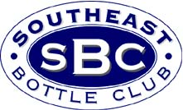
Greensboro Antique Bottle & Collectibles
Show & Sale
Info Package Guide
Show Date: Sunday November 21, 2004, 9am-3pm
Dealer Setup: Sunday 6:00-9:00am
Early Buyers: $10 Sun 7:30-9:00am

Welcome to the 3rd Annual Greensboro Antique Bottle & Collectibles Show & Sale. The show will once again be located at the Greensboro Farmer’s Curb Market, whose 8500 square foot indoor heated facility provides the capacity for up to 162 dealer tables.

This package has everything a prospective dealer or collector needs for the show. Dealers should reserve their tables as early as possible since a sell-out is expected. October 21, 2004 is the deadline for reserving the same table you had last year. Two copies of the Dealer Contract are included. The show is being advertised extensively in all bottle magazines, numerous antique publications, local newspapers, and at area bottle shows and antique malls in NC and the surrounding states. And it will also be promoted in the Southeast Bottle Club newsletter, which is distributed monthly to over 3600 collectors. This will help guarantee a large buying crowd for our dealers.

The show will emphasize the sales of antique bottles, insulators, and related go-with’s. Dealers are allowed to add other table-top antiques and collectibles to their tables, as long as some of their items are antique bottles or related go-with’s. The “no beanie babies” rule will apply. We are giving away free bottles to kids (i.e. next generation bottle collectors), so please bring any nice, inexpensive bottles that you can donate.

Show Info: contact Reggie Lynch (919) 789-4545, PO Box 13736, Durham, NC 27709. The show web page www.antiquebottles.com/greensboro has the full contents of this show package.
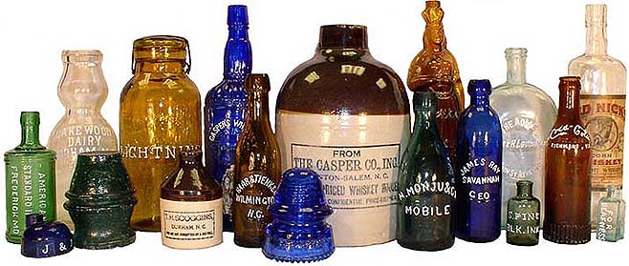
Visitor Info: For a free Greensboro visitor info packet, contact the Greensboro NC Convention and Visitors Bureau at (800) 344-2282 or online at www.greensboronc.org

Hotel | Phone | Location | Map | Rate
Days Inn | (336) 297-1996 | 3304 Isler Ct off High Point Rd & I-40 | F | $54
Econo Lodge | (800) 553-2666 | 3303 Isler St. off High Point Rd & I-40 | F | $37
Holiday Inn Express | (336) 697-4000 | 3114 Cedar Park Rd exit 128 off I-40/85 on Lee St | E | $65
Red Roof Inn Coliseum  (recommended) | (336) 852-6560  (800) 843-7663 | 2101 W. Meadowview Rd.  near Coliseum on High Point Rd. | G | $39
Super 8 Motel I-85 | (336) 273-1983  800-800-8000 | 204 Seneca Rd.  Exit 125 off I-85 on Elm/Eugene St | H | $46
Motel 6 Greensboro South | (336) 854-0993  (800) 466-8356 | 831 Greenhaven Dr.  Exit 122C off I-85 S. | I | $33

Restaurant Info: During the show, food and drinks will be available in the show building. The best/closest restaurant selection is along High Point Rd from Holden Road to the Coliseum (D on the map). Stamey’s BBQ is across the street from the Coliseum. There is another good restaurant stretch along Battleground Ave from Wendover Ave to New Garden Rd. Also see the restaurant section at www.greensboronc.org

