The RALEIGH BOTTLE CLUB
Presents its 2nd Annual
ANTIQUE BOTTLE
& COLLECTIBLES
SHOW & SALE

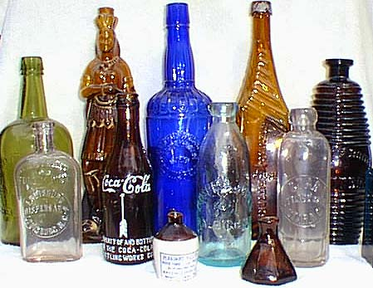

Saturday April 27, 2002
9:00am-3:00pm / Free Admission
NC State Fairgrounds – Raleigh
In the Holshouser Building
Dealer Setup 6:00-9:00am, $15 Early Buying 7:30-9:00am

127 Dealer Tables / Free Bottle Appraisals
Free Bottles for Kids / Fantastic Displays / Plenty Free Parking

Same weekend as Apr 26-27 Liberty NC Antique Festival

Flea Market on Fairgrounds same weekend
Directions: from I-40, take Wade Ave, then exit at Blue Ridge Road and
turn right. State Fairgrounds will be 1/2 mile down on right at
intersection with Hillsborough Rd.
Info: Reggie Lynch (919) 789-4545
Addr: PO Box 13736, Durham, NC 27709
Web: www.antiquebottles.com/raleigh
Email: raleigh@antiquebottles.com

The Raleigh Bottle Club is a non-profit organization serving the community

